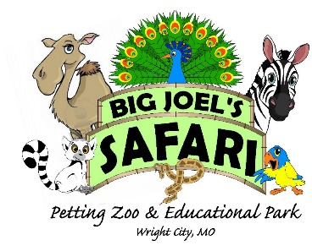 | Big Joel’s Safari Petting Zoo & Educational Park Employee Application  2022 Season

Employment Application

Applicant Information
Full Name: |  |  |  |  |  |  | Date:
 | Last |  | First |  |  | M.I.
Address:
 | Street Address |  |  |  |  |  |  |  | Apartment/Unit #
 | City |  |  |  |  | State |  |  | ZIP Code
Phone: |  |  |  | Email
Position Applied for (please check one) : |  | Safari Ambassador Safari Team Member Animal Care Position

Are you a citizen of the United States? |  | YES | NO | If no, are you authorized to work in the U.S.? |  | YES | NO
Have you ever worked for this company? |  | YES | NO | If yes, when?
Have you ever been convicted of a felony? |  | YES | NO
If yes, explain:

Education
High School: |  | Address:

From: |  | To: |  | Did you graduate? | YES | NO | Diploma:

College: |  | Address:

From: |  | To: |  | Did you graduate? | YES | NO | Degree:

Other: |  | Address:

From: |  | To: |  | Did you graduate? | YES | NO | Degree:

References
Please list two professional references.
Full Name: |  | Relationship:
Company: |  | Phone:
Address:
Full Name: |  | Relationship:
Company: |  | Phone:
Address:

Previous Employment
Company 1: |  | Phone:
Address: |  | Supervisor:

Job Title: |  | Starting Salary: | $ | Ending Salary: | $

Responsibilities:

From: |  |  | To: |  | Reason for Leaving:
May we contact your previous supervisor for a reference? |  |  |  |  |  | YES | NO
__________  Company 2: |  |  |  |  |  |  |  | Phone:
Address: |  |  |  |  |  |  |  | Supervisor:

Job Title: |  | Starting Salary: | $ | Ending Salary: | $

Responsibilities:

From: |  | To: |  | Reason for Leaving:
May we contact your previous supervisor for a reference? |  |  |  |  | YES | NO

Special Skills/ Experience
List any special skills/ experience: ______________________________________________________________________________________________________________________________________________________________________________________________________________________________________________________________________________________________________________________________________________________________________________________________________________________________________________________________________________________________________________________________________________________________________________________________________________________________________________________________________________________________________________________________________________________________________________________________________________________________________________________________________________________________________________________________________________________________________________________

Disclaimer and Signature
I certify that my answers are true and complete to the best of my knowledge. If this application leads to employment, I understand that false or misleading information in my application or interview may result in my release.
Signature: |  | Date:

